Please see my comments in **Red** color.

A custom table would be built that would contain the following fields, at a minimum.

PO#

PO Internal ID

Vendor Name

Vendor Internal ID

Item

Item Internal ID

PO Line ID

Qty

Expected Receipt Date

Inbound Shipment #

Status

We can create a **custom record type** as below. Please see the below screen.

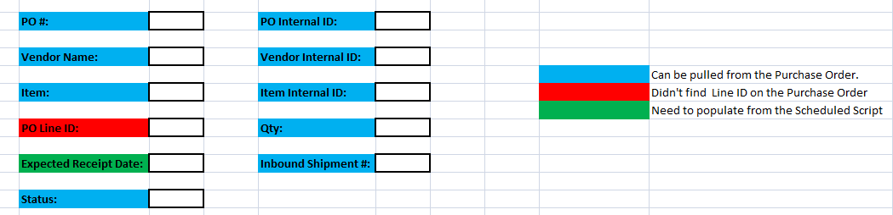

What if there are multiple line items on the Purchase Order? Do we need to create an item sublist on the custom record type (or) there will be always one line item on the purchase order? Please suggest.

When a purchase order is created the line level information would be initially loaded into the custom table.

We can create an after submit user event script to populate the custom record type when the purchase order is created. What are the required fields need to be populated on the custom record type?

A custom checkbox would be created on the Inbound Shipment line level.

We can create a Other Sublist field at the line level.

A scheduled script would run to pull those new Inbound Shipment lines where the checkbox is FALSE and add them to the custom table, then mark that checkbox as TRUE on the inbound shipment line

We can write a script to pull the inbound shipments and what are the required fields that needs to be populated on the custom record type when we pull the inbound shipment lines?

A saved search could then be developed around the custom table that would allow you to pull both PO’s not assigned to Inbound Shipments and Inbound Shipments.

What are the both PO’s? I didn’t understand this point. Could please elaborate it?

There would be a scheduled script that would cycle through the custom table with logic such as ‘if Inbound Shipment field is NULL get expected receipt date from PO Line else get expected receipt date from Inbound Shipment’.

We can create a script on custom record type to search through all the records where expected receipt date is NULL and populate it.

The expectation is when the Inbound Shipment detail is loaded into the custom table, it would be added to the previously created PO Line in the custom table.

Could please elaborate it with an example test records?